Title: What connects social worlds across spaces? A reflexive look at an international research collaboration

Michelle Elmitt, University of Canberra, Australia
Temesgen Beyene, Bahir Dar University, Ethiopia

In the following paper, we present a case-study of an international research collaboration between an Australian doctoral student and an Ethiopian field practitioner to illuminate methodological, philosophical and existential principles of conducting international ethnographic research at PhD level. We compare our case to the mounting literature on international research collaboration. We highlight relatively unexplored areas in communication and practice and we outline the benefits that our more intuitive approach brings to intercultural collaborations.
This case-study, drawing on our archive of written and photographic communication and our individual fieldwork findings and interpretations, illustrates one way of approaching the challenges of intercultural research while keeping the differing perspectives of the researchers alive. Issues such as translation, time constraints and the overwhelming nature of carrying out field research in a field previously unknown to one researcher, are challenging, as are budget constraints.
Each of us have individual academic agendas and we have agreed to collaborate on a specific field work experience that is part of Michelle Elmitt’s PhD in Communication. This paper discusses the way we are undertaking this collaboration as well as referencing Temesgen Beyene’s field archive. We a share focus on ethnographical fieldwork and subjective narratives inside an ontological framework that can accommodate disjuncture between Western perspectives and African realities. We support taking a reflexive and flexible approach.
Here we discuss ways to frame, design and carry out unsponsored research that combines two contrasting perspectives, world views and lived realities —the same two perspectives that make the research important, particularly regarding Michelle’s doctoral study in non-biological kin relationships. We make a case for persevering with physical and translation complications to increase our opportunities of discovery. In doing this we highlight the critical value of multidisciplinary methodology design. What we approach as our challenge is to explore difference and incommensurability, keeping both perspectives alive.
The premise is that our embarking on this journey of unrehearsed, intuitive research, learning as we go, will a) produce valuable data for Michelle’s PhD, b) afford Temesgen the opportunity to share his ethnographical knowledge of the Ethiopian people and folklore, and c) add value to the literature on the methodology of international field research. We will explore the way our research relationship is developing under the radar, with limited research funding, no sponsorship and no formal contract between us, purely as two fellow travellers seeking to expand and share knowledge. From two perspectives — assumedly oppositional regarding gender, race, age and ontological positions — we share our collaborative journey so far and compare our case to the mounting literature on the strengths and pitfalls of international collaborative research.
“The world is like a mask dancing. If you want to see it well you do not stand in one place” (Chinua Achebe 1959).
Keywords: ethnographic; international collaboration; reflexivity; Ethiopia

Collaboration Background
This paper is about an international research collaboration between two researchers, one Australian and one Ethiopian, who operate in very different lived realities, having different but overlapping research agendas. Both examine family and kinship practices. Michelle Elmitt and Temesgen Beyene have come together to collaborate in ethnographic field research. This paper will describe what both are doing individually and question how it is possible to work together. In highlighting the difficulties and the differences apparent in such intercultural research we discuss that it is just these things —the differences and issues of translation —that make the work valuable.
We offer original insights generated by this case study of our working relationship to date. Perhaps the most striking finding is that the simplicity and directness of our pragmatic approach to meeting, communication, planning and sharing knowledge, has allowed us to sidestep many of the issues reported in the literature on international, multi-sited research collaborations. We move ahead with an increasing understanding of the differences in Ontology, epistemology and lived experience of kinship practices and keep alive the two perspectives.
In this paper we will review the literature and then present some data that demonstrates the way our collaborative relationship is developing. We will use this data to analyse how we are doing things compared to, and differently to, some other research collaborations reported on international, multi-sited research collaboration. Finally we will discuss the values and difficulties of this collaboration.
Michelle Elmitt’s PhD in Communication is titled: ‘Reconfigured family: possibilities of love’. This is an investigation of the cultural intelligibility and possible articulations of love in relationships between parents and non-biological children in contemporary society. Michelle is examining the social intelligibility of kinship, looking for ways that emotional connections within changing family arrangements are articulated and performed. She is responding to Poststructural and Postcolonial theories on kinship, and using discourse analysis and performativity, along with the creative writing process, to explore the way love is transacted. She will be examining relationships influenced by prevailing cultural and social norms and discourses in global contemporary contexts. She will examine one cohort in Australia where the practice of parenting other people’s children has been increasing in occurrence in the last few decades, and one in Ethiopia, where the custom is not exceptional.
The design of the Ethiopian fieldwork component of the PhD research is complex. We employ visual ethnography and semiotics as methodology, which overlaps with the methodology of this case-study, and we also refer to Africanisation and accept plural ontologies to accommodate our two very different research paradigms and lived realities. In the interpretation of the data Michelle will refer to the work of Elizabeth Povinelli who has devised the concept of genealogical and intimacy grids to make sense of two archive’s “seeming oppositionality” (Povinelli 2002, p. 238), thus making comments on social worlds possible by the “connectivities and irreducibilities” (p. 238). Visual ethnography is a method suited to both studies as the focus is not on attempting to draw conclusions but to lead to “making the linkages through the unstable elements of literature and life —the dangerous tryst with the untranslatable—rather than arriving at ready-made names" (Bhabha 1994, 325). The choice of visual ethnography as methodology for both projects is thus explainable on many levels. This approach lends itself to analysis that does not rely on contrast and dichotomy.
We have chosen to present Temesgen Beyene’s research paper, The Diagnostic Methods of Diseases, Medical Prescription and Administration of Folk Medicine in “Gishe” District: A Short Presentation of Northern «Shewa» Folk Medical Practice (2014) by way of information boxes throughout this paper to demonstrate the rich data we are accumulating in this collaboration. Temesgen’s thesis examines and shows diagnostic methods of folk medical practitioners’ activities, the prescription and administration process of folk medicine, and questions why people use folk medicine and how folk medical practitioners examine and diagnose different diseases. He describes the acquisition and transfer system of folk medical knowledge and secrets. Further aims of his project are: to preserve, collect and document the village activities that comprise folk medical knowledge and wisdom. We include some material from Temesgen’s archive, including the symbolic representation and interpretation of folk medicine.
The collaboration outcomes we are hoping for are, like our collaboration itself, is original. So what does he get out of it? And what does she get out of it? The question is really: why would two people with no former knowledge of each other, with great variance in age and life experience, commit to performing collaborative field research and further agree to document their working relationship for others to critique? Of course what we get out of it is the excitement and danger of venturing into the unknown, with the hope of discovering meaning, and with some sense of freedom in the way we work together which is not scripted by historical conventions. What we also plan to achieve is rich data for Michelle’s doctoral dissertation and a bigger platform for Temesgen’s unique and valuable field work on folk medicine.

Theoretical Background
Research that treats issues across cultures has become popular in the last 30 years as the world becomes more connected politically and economically. As Ou et al. (2012) discuss, financial and political events or disasters occurring in one country can quickly impact on others around the world. With this comes the demand for multidisciplinary and multinational knowledge (p. 438), particularly in international business, finance and management literature (e.g. Jarzabkowski et al 2014, Gille & O Riain 2002).

There is also increasing support for international research in the social sciences and humanities where globalization challenges existing social scientific methodology and analysis “by destabilizing the embeddedness of social relations in particular communities and places” (Gille & O Riain 2002, p. 271). These authors believe globalization suggests the “increasing significance of trans-local relations, local-global relations, and global-global relations at the expense of national-national relations” (Gille & O Riain 2002, p. 273).

Along with the increase in inter-national research for political, social and management purposes we are seeing that publication and grant opportunities are increasingly available to international research. Karra & Phillips (2008, p. 542) find that there are an increasing number of business schools located outside of North America and Western Europe that expect their faculty to publish in international journals. Ou et al. (2012, p. 431) also find that despite the many challenges, scholars find international collaboration is necessary for publication success. Similarly, Jonsen et al (2012) report that scientists and academics increasingly work on collaborative projects in international research teams. The trend, they say is driven by greater demands for publication “in terms of the quality and breadth of data and analysis methods, which tend to be difficult to achieve without collaborating across institutional and national boundaries” (p. 394).

These trends, emerging in the last thirty years, impact on the way research is conducted in the humanities which has more commonly been the province of solo academics, involving little direct collaboration with others. The model has been reinforced through doctoral studies and beyond (Newell et al. 2000; Cuneo 2003 cited in Ou et al. 2012). As research questions become more complex and technologically sophisticated, (Newell et al. 2000; Hara et al. 2003, cited in Ou et al. 2012) various authors argue that a team approach is increasingly a requirement. Hine (2007, p. 658) follows Latour in saying that sociologists should move their study out of the level of the laboratory. Hine follows Law and Urry’s (2004, p. 663) proposition that social reality is constituted not reflected by methods in social science, and their warning that “methodological instincts are to clean up complexity and tell straightforward linear stories, and thus we tend to exclude descriptions that are faithful to experiences of mess, ambivalence, elusiveness and multiplicity” (p 663). These authors believe that there should be focus on the researcher's agency and as the constructor of reality.

We believe that there are benefits in conducting unsponsored collaborative research in the value of the data and analysis we can produce in two different realities. Without sponsorship restrictions, by combining our diverse areas of institutional guidance, practice and knowledge, we can also design methodology and that does not favour the dominant paradigm and will not be biased by linear laboratory type methodology. As we will demonstrate we will be researching deep in the field literally, with no exclusions, constructing a methodology that can contain plural ontologies and situate both researchers as actors in the research scenario.
When we agreed to embark on this collaborative research journey we were not aware of the growing pressure to research across cultures, believing that examining kinship practices between cultures was more valuable than researching in isolation. In this case the impact of Michelle’s study is investigating kinship where there is an established practice of parenting other people’s children, in Ethiopia, as opposed to a culture where the practice is more recently becoming established, in Australia. Now we are underway the question Gardner et al. (2012) provoke us to ask is: how can MA/ PhD level researchers demonstrate the value of involvement in international research to their institutions, academic teams and colleagues, especially in the early stages of the project? This all takes time and publications are not instantly evident (Engelbrecht et al. 2014, p. 13). We hope to demonstrate the value of our collaboration by recording the steps we take to design methodology and execute the fieldwork, reflecting on our process, in the form of academic papers.
Now we will discuss a range of issues and challenges regarding problems that researchers face while carrying out research projects in unfamiliar cultural contexts. Language is critical to understanding and knowledge building. Vygotsky (1978) cited in Engelbrecht et al. (2014, p10) names language as “the tool of tools.” Engelbrecht et al. pursued this theme — of using language to clarify context — in their own research by undertaking a critical oral analysis of each team member’s “countries’ cultural and socio-political biographies followed by intense discussions and references to literature and documents to help gain a general understanding of contexts” and grounding of terminology (2014, p. 10). Our project is subject to issues of linguistic and cultural translation which we will further address when we discuss methodology in this paper. We extend undertaking of the cited authors to our collaboration but include more than spoken language, highlighting the benefits of visual language in knowledge building and synergy, as more than oral language is involved in the complex, messy experience of life. As we will discuss later, visual languages and performances communicate socio-cultural processes too.
Crossing social boundaries in research teams has also been identified as problematic by authors such as Thomas et al. (2009). They cite Beech and Huxham (2003), who find distinctions between “us” and “them/other” are brought into sharp relief (p. 322). Thomas et al. say that, apart from a few notable exceptions (May et al. 2000; Mountz et al. 2003; Stanley & Slattery 2003), there is a “limited reflexive analysis of the personal and power dynamics within research collaborations” (2009, p. 322), regarding how distances and differences are managed. They call for researchers to be accountable not only to research subjects and readers, but to colleagues. They are among theorists who argue that a reflexive practice is essential. Ou et al. (2012) note that traditional teamwork literature is not specific to academics undertaking international collaboration, claiming their “study is among the first to provide theory-based and empirically supported factors contributing to success in international academic collaboration” (p. 410). In considering how to align differences in competencies and academic cultures, Engelbrecht et al. (2014, p. 13) find personal and institutional expectations are problematic.
The complexity of designing research and theoretical frameworks can be fraught when collaborations include individuals with contrasting histories and interpretative frameworks, and potentially even more challenging when the collaboration is cross-cultural (Easterby-Smith & Malina, 1999). Thomas et al. (2009) also highlight power relations involved in research collaborations. They aim to reveal some of the “hidden and silenced aspects of research collaboration” by drawing attention to the “culturally and theoretically informed interpretive repertoires of the researchers and how this influences research dynamics, processes, and products” (p. 319). They commend pursuing reflexive and ethical relationships.

As already indicated, the expectations of the associated institution and the funder can weigh in when designing and practising international collaborative research. This, in our case, applies to the expectations of the University affiliations of the two researchers and the conditions of ethical approval. Student international collaborative research has been discussed by Jonsen et al. (2012) stressing the benefits and the necessity of support at the institutional level. These authors practice a reflexive, autoethnographic approach to investigate their own experience in international collaborative research. The insights offered are on social and intellectual processes of academic collaborative writing, which they believe may benefit the formation of teams, the preparation of research proposals, and the development of PhD curricula.
Jonsen et al. find that the crux of the matter is to align research objectives with the right approach and methods and agree with Teagarden et al.’s (1995, p. 397) argument that “the challenge of alignment is likely to be manifold because it means bringing together members’ potentially very different interests, backgrounds, and perspectives”. They note again that there are complex differences between international and domestic research regarding diversity in interests, cultures, and ontologies among researchers. This is what we find enticing about undertaking this type of investigation: it allows the possibility of perspective.
We will now look at the rewards of this type of research and the values of adopting an ethnographic methodological approach. The benefits of conducting international collaboration in qualitative and quantitative fields are arguably the stimulation of intellectual creation, the dissemination of knowledge and the integration of skills and resources (Katz & Martin 1997; Lee & Bozeman 2005, cited in Ou et al. 2012, p. 411). Ou et al. also claim that international collaboration provides a “better way to achieve synergy” between scholars operating in dominant and non-dominant paradigms (p. 439).

Ethnography allows for the study of culture and the interactions of individuals within a specific social context from the point of view of the subjects, including their relationships to the researcher. It is a way to gather understandings of complex emotional and ritualised behaviours and allows the interpretation of data to be context related. Discourse analysis is one way to interpret such subjective data. The place of ethnography in multisite international research has also come under scrutiny recently. Jarzabkowski et al. (2014) discuss the methodological implications of the shifts from single to team researcher, and from single site to the multiple case sites, in global ethnography. They review their own global, team-based ethnography, in the reinsurance industry, in this light. They acknowledge that space is socially produced in field work practices (Lefebvre 1991;1974), and question the idea that the ‘local was an adequate form of ethnographic space’ (Falzon 2009, cited in Jarzabkowski et al. 2014, p. 5). These notions have changed the conceptualisation of ethnographic practice. In more traditional ethnography a single ethnographer produces a subjective ethnographic narrative of the experience, acknowledging the situatedness of their position. As Britzman (1995) cited in Gerstl-Pepin & Gunzenhauser (2010) notes: ``Ethnographic theorizing has become more tentative and less concerned with the old struggles of establishing authority as a way of research; it is more concerned with the archaeology of construction, the sedimentary grounds of ethnographic authority’’ (p. 231). Gille and O Riain (2002, p. 279) describe ethnography as “able to strategically locate itself at critical points of intersection” making it possible to “examine the negotiation of interconnected social actors across multiple scales”.

Locating research in place still provides a foundation for global ethnographers despite the challenges that globalization poses for sociology practice, particularly in applying qualitative methods in fieldwork (Gille & O Riain 2002, p 272). Gille and O Riain extend the idea of the social as flow or network, following Lash & Urry (1994) who argue that “this disembedded “social” is increasingly constituted by flows of people, information, goods, and particularly signs or cultural symbols” (p. 274) so that “mobilities,” replace the concept of “community.” This is a concept that is particularly relevant to both of us. Michelle’s research, in response to Judith Butler’s theories of kinship, examines the way people move in and out of families, and with this movement is a flow of material, emotional and symbolic signs. Ethnographical practice, including visual ethnography, is the chosen methodology to capture such phenomena.
The interpretation of globally collected data also opens up new areas of negotiation and challenge. Wasser &Bresler (1996, p. 12) find collaboration to be at the heart of the interpretive process. They see that collaboration serves a critical interpretive function by affording perspective (p. 12), as well as allowing the researcher to cover more sites, gather more data and thus make a case for being more comprehensive. With heterogeneity as the basis for interpretive work these authors learned that, for collaboration to have methodological value, allotment of enough time for collaborative interpretation is essential. They report finding benefit when constructing concepts by including pictures and images, “allowing us to see the mental space in which we were working as a group as “the interpretive zone” (p. 13). They describe this zone as an intellectual realm where meanings can be made from “different kinds of knowledge, experience, and beliefs” (p. 13).

According to Hine (2007) the shift in terminology from ethnography to imaginary, as defined by Marcus (1995) “marks an embrace of the constructed nature of research projects, and of the agency of the researcher in determining the focus.” Hine discusses Merton's request for “middle range theory” identification of a tension between engagement on site and intervening coherently on issues (p. 656), saying that for Marcus, “the multi-sited approach feels necessary in many circumstances as a faithful reflection of lives lived not in discrete locations, but through various forms of connection and circulation” (p. 657).
Gerstl-Pepin and Gunzenhauser (2010) examine the paradoxical process of interpretation in collaborative team ethnography. From their work on a collaborative team evaluation in a Schools Program, they review the way the research collaborator’s various viewpoints, experiences, epistemology, races, genders, class backgrounds, and research interests entangle their ability to interpret data. The authors address three paradoxes on the research team: interpretation, diverse representation, and conflict in roles of evaluation and criticism. They claim that “multiple layers of collaboration led to greater understanding through multiple meanings but, paradoxically, greater fragmentation and uncertainty” (p. 137).

Further to our discussion on ethnographic practice we now refer to John Van Maanen (2006) who reviews some of the shifts in composition and orientation that have occurred in ethnography during the last 20 years. He comments on a continued focus on the empirical and a lack of what he considers to be standard methodology. He also describes the move to multi-site study, saying ethnology has become de-territorialised with “the rise and expansion of vast human migrations, vanishing native groups, market globalization, enhanced information, communication and transportation technologies, the anthropologizing of the west,”(p. 15).
Clifford Geertz (1973) advocates a semiotic concept of culture: “Believing, with Max Weber, that man is an animal suspended in webs of significance he himself has spun, I take culture to be those webs, and the analysis of it to be therefore not an experimental science in search of law but an interpretive one in search of meaning” (p 6).
Clifford Geertz quotes Wittgenstein:
We [...] say of some people that they are transparent to us. It is, however important as regards this observation, that one human being can be a complete enigma to another. We learn this when we come into a strange country with entirely strange traditions; and, what is more, even given a mastery of the country’s language. We do not understand the people. (And not because of not knowing what they are saying to themselves.) We cannot find our feet with them. (Wittgenstein, 1958, p. 223).

Geertz believes that the aim of unravelling understandings is one which a semiotic concept of culture is well adapted for. “As interworked systems of construable signs (what, ignoring provincial usages, I would call symbols), culture is not a power, something to which social events, behaviours, institutions, or processes can be causally attributed; it is a context, something within which they can be intelligibly —that is, thickly— described”(p. 6).
Characteristics that facilitate international collaboration have been identified by researchers working within the models discussed so far. Siemens et al (2013) identify ‘soft skills’ such as: patience, particularly concerning language; listening skills, and the need to be friendly, open and humble as requisites of team research (p. 332). They also identify the importance of knowing about the rites or norms of communication, for example forms of address (p. 338). They confirm the importance of colleagues gaining important cultural knowledge with face-to-face meetings, either by traveling to partners or by exchanges (p. 339). Above all, they believe in the importance of a shared understanding of the research. Wasser &Bresler (1996) reinforce the very social nature of the research process (p. 5). The researchers have connections to the participants as well as numerous others, during the course of a project and all contribute in some way to interpretations made. They believe that there is still need for researchers to address the relationship of researcher to researcher and the role this plays when interpreting data and the co-construction of knowledge.
Our collaborative endeavours, as they progress, will contribute to an area of interest identified by Wasser and Bresler (1996) who find the lack of scrutiny of group interpretive processes in the field of qualitative researchers in education surprising (p. 6). Again regarding issues of interpretation, Wasser and Bresler believe that interpretation cannot be separated from issues of values. Following Feminist research they question ways that gender and other significant historical, political, or social features effect group interpretation (p. 6). Although our research is not in education we will be reflecting on the process of our data interpretation, keeping our separate political and social stances alive in the process. We agree that the interpretation of the data should be scrutinised and made explicit to the reader. This is one of the most valuable and fascinating parts of the process.
Collaborative interpretation is a performative, pedagogical act according to Gerstl-Pepin and Gunzenhauser (2010). Following Ellsworth (1997), they see that the collaborative team comes together with “individual contextualized research experiences that can include the unconsciousness elements in dialogue” (p. 141). In their struggle to interpret data collaboratively Gerstl-Pepin and Gunzenhauser acknowledge “there are too many people, desires, and too much power in the room for any of it to be just dialogue” (p. 141). Gerstl-Pepin and Gunzenhauser believe that the conventional imaginary of dialogue is not possible and they call for “exploration of the third space, the unconscious elements in what are called dialogic situations (but are indeed tri-alogic)” (p. 141). This is a different context and definition to that of Bhabha’s concept of the third space that we will discuss later, but sits well with our intention of approaching fieldwork from two perspectives that differ consciously and unconsciously. What we approach as our challenge is to explore difference and incommensurability.

Gerstl-Pepin and Gunzenhauser agree with Wasser and Bressler (1996), who argue that collaborative ethnography strengthens the interpretive process by dealing directly with the strengths and weaknesses of subjective analysis (p. 152), while pointing to the fragile nature of understanding other perspectives outside of the researcher’s experience. This is the challenge not only for the researcher but for the audience in our case. They also agree with Ellsworth (1997) saying that the paradoxical pedagogical relation is not a tension to be resolved or the possibilities for engagement and meaning would be limited. They promote letting go of focus on the power of dialogue for continuity (p. 152).
Following from the discussion of ethnography as a method to investigate the ways a subject and social institutions, such as kinship and family, interface, we will now discuss the relevance of Postcolonial theory to our work. Unlike Australia, Ethiopia was never colonised. To analyse the way prevailing historical discourses and power imbalances impact on the way individuals perform in different social conditions involves seeing some situations and relationships as constituted in oppressive circumstances. Authors such as Thomas et al. (2009) describe the “compelling arguments from Postcolonialism and Feminism that “facts” produced within the discipline are at best partial truths, historically and culturally bounded” (p. 314). This position is taken by authors such as Bhabha (1994); Haraway (1991); Harding (1986); Said (1979). As Westwood (2001), cited in Thomas et al. (2009), comments, cross-cultural management research “pretends to an objective presentation, but it can only talk about them in a language informed by its own localized and historically situated ontologies, epistemologies and moralities” (p. 314).
Our undertaking is to work within Postcolonial scholarship by envisaging interaction as occurring in a sociolinguistic space referred to by Homi Bhaba as third space theory. This theory illuminates the way shared understandings of culture are collected over generations and, as in the postcolonial situation, representations are effected by power imbalances. Scholars such as Edward Said and Homi Bhabha have influenced researchers to delve further than the superficial differences between cultures when considering the subject position and to investigate, what Bhabha calls the third space, where understandings are made possible from the articulation of differences. Our intention in the forthcoming fieldwork is to give voice to some of the multiple ways families reconfigure in varying circumstances. To keep the possibility of a third space of interaction alive in our own research relationship, where language and cultural meanings are open to interpretation, we intend to examine meanings by methods other than written and spoken language in our “in-between reality.”
This is the moment of aesthetic distance that provides the narrative with a double-edge, which like the coloured South African subject represents a hybridity, a difference ‘within’, a subject that inhabits the rim of an ‘in-between’ reality. And the inscription of this borderline existence inhabits a stillness of time and a strangeness of framing that creates the discursive ‘image’ at the crossroads of history and literature, bridging home and the world (Bhabha, 1994:19).
To date things have been unfolding as we go and we have taken the approach of instinctively delegating tasks. For example: Michelle is better equipped to find articles for literature reviews, while Temesgen is spending a great percentage of time in the field in Ethiopia, forming relationships with Ethiopian people whom Michelle has not yet met, and documenting field notes for future planning and reflection. As Gerstl-Pepin and Gunzenhauser (2010) have stated, part of the research process is that the researchers learn from each other as well as from the participants (p. 140). This concept they base on Ellsworth’s (1997) notion of pedagogy as being “a much messier and more inconclusive affair than the vast majority of our educational theories and practices make it out to be’’ (p. 8). Wasser and Bresler (1996) ask at what junctures in the process are “new considerations added, rejected, or rewritten and how?” (p. 7). As to this question of planning and leadership we defer to each other’s expertise pragmatically. What we each get out of it is unfolding.

Methods
We will now present our case-study and link our progress to the research findings already discussed. We promote a flexible, pragmatic approach to international collaboration and discuss our methods of alleviating difficulties with translation without losing the value of the different perspectives. The data we present consists of cuttings from a selection of email transcripts (February to September 2014) and samples of Temesgen’s field notes and photographs, as well as one shared personal anecdote that illustrates our collaborative journey. This data is presented along with our reflections on the challenges and achievements to date. As Hammersley (1990, p. 598) states, descriptions cannot be theories, but all descriptions are theoretical in the sense that they employ concepts and theories.
We are employing a reflexive methodology for this case study.
We take the meaning of reflexivity to be active consideration of the implications of what has been observed for the observer's own practice. Reflexivity is deemed by some to contribute significantly to sense-making in cross-cultural collaborative research teams (Easterby-Smith & Malina, 1999, p. 77). Engelbrecht et al.’s (2014) paper identifies five stages of international collaborative research. The authors find that the associated steps are connected by a practice of reflexivity (p. 1).
They have identified lack of a cohesive theory regarding the underlying processes involved in collaborative knowledge building (p. 3). We are encouraged by Jonsen at al. (2012) and Thomas et al. (2009) also calling for more reflexive analysis of collaborative research in order to understand its dynamics, as well as Karra and Phillips’ (2008) proposal that “researchers need to learn to see their own culture, and then they need to translate what they see for publication in international journals” (p. 542). Easterby-Smith and Malina (1999) also made a case for a more reflexive approach to ongoing research collaboration, suggesting that by working together and observing each other in action, international research teams build trust and come to understand and value different approaches (p. 76).
Thomas et al. (2009) make a point, pertinent to this case study, that a number of disciplines involved in the study of cultures have questioned the imperialist nature of knowledge production. Our intention is also to “recognize multiple voices” and reflexively consider how each other’s information and knowledge of the field is constructed, interpreted, and reported (p. 315). Easterby-Smith and
Malina (1999) argue that few writers have explored the dynamics of academic collaborations or reflexively engaged with the complexities of collaborative cross-cultural research (p. 77).

Debating the political nature of representation Edward Said wrote: “The point is that anthropological representations bear as much on the representer’s world as on who or what is represented” (Said 1979, p. 224). Thomas et al. (2009) propose undertaking a “purposeful agenda for transforming the institution of research, the deep underlying structures and taken-for-granted ways of organizing, conducting, and disseminating research and knowledge.” They argue that reflexivity should encompass the entire research project (p. 317).

They attempted to practice what they call “radical reflexivity”, which involves turning the reflexive gaze onto themselves as researchers and questioning the “truth claims” we make and the ways we have constructed reality. This is a tactic we are intuitively able to use in our correspondence, having established a relationship whereby Temesgen has been able to interpret some life events that involve Michelle’s family. We will explain the particular occurrence that lead to this understanding later in the paper.
Semiology is another methodological approach that befits both this case study on collaboration and the interpretation of the ensuing field work. For Clifford Geertz (1973), “The whole point of a semiotic approach to culture is […] access to the conceptual world in which our subjects live so that we can, in some extended sense of the term, converse with them”(p 12).
By including some of Temesgen’s photographic archive we are demonstrating the powerful communicative ability of photography and visual language. Again we refer to Geertz’s (1973) opinion that anthropological interpretation involves formulations of other peoples’ symbol systems and is actor-oriented (p 7). Cultural forms find articulation through social behaviour and action. We have included samples of some of Temesgen’s field archive of the various cultural groups that constitute Ethiopia, and family scenes where rituals are evident. For example, family dinners may involve a group sitting and sharing food from the one plate. Roland Barthes (1972), in discussing the way semiology can be interpretive of variations of social life, warns that
enormous common sense and understanding must underlie and precede any formal analysis. Hence, one can see the essential role of fieldwork in connection with formal semiotic analysis. (Barthes 1972, p. 43)
In terms of research ontology we consider we are well situated with Otherwise ontology. The research we have planned is multidisciplinary: including the disciplines in Michelle’s PhD which are Ethnography and Creative writing, and Temesgen’s MA in Cultural Linguistics, and Folklore. There are some obvious similarities in these humanities disciplines regarding analysis of the way the subject performs various roles in society and how this is observed and described. Creative writing provides a way to communicate some of the more complex, emotional phenomena involved in family relationships. We refer again to Homi Bhabha’s (1994) use of literature as a way of capturing the experiences and transitional moments of individuals living in changing societies. Bhabha refers to the literature of V.S. Naipaul:
Naipaul’s people are vernacular cosmopolitans of a kind, moving in-between cultural traditions, and revealing hybrid forms of life and art that do not have a prior existence within the discrete world of any single culture or language. (Bhabha 1994, p. xiii)
This description also favours the links we make between the disciplines of creative writing and ethnographic fieldwork in a postcolonial world.
The ontological framework is that there are multiple socially-constructed realities globally and truth is context dependent. We refer to Otherwise ontologies to increase the possibilities of understanding inter-cultural ethnographical analysis and social transformations. The understanding we have of Otherwise ontologies comes from Benjamin Alberti:
consider the difference that pluralizing ontology might make and whether such a move is desirable given the aims of archaeology and anthropology. While several angles on ontology come through in the conversation, all share an interest in more immanent understandings that arise within specific situations and that are perhaps best described as thoroughly entangled rather than transcendent and/ or oppositional in any straightforward sense. (Alberti et al. 2011, p. 896)
This ontology lends itself to the Bhabha’s way of looking at the way the subject is formed in the context of the collision of social worlds.
We favour the interpretivist paradigm and include the terms of the 1996 UNESCO request that research in Africa not be based on the dominant paradigm of western industrialisation. The UNESCO decree states that research should be based on African values, experiences and principles. According to this decree collaboration is the only option for doing research in Africa. The obligation is to develop a research methodology that ensures “African value systems of connectedness to the earth and ancestral spirits, and their oral traditions and indigenous knowledge systems [are] part of the methodology and research questions” (Chilisa et al. 2005, p. 12). This approach also supports an undertaking to conduct “research in such a way that the worldviews of those who have suffered a long history of oppression are given space to communicate from their frames of reference and world views” (p. 23).
Further, to unravel ways that enmeshed subjective experiences can be translated, we are working with the following terminology and ideology: Africanisation: meaning that the African world view is at the centre of analysis; African Renaissance: describing the way African scholars have redefined themselves in their own terms, and Ethnophilosophy: describing the collective worldviews encoded in folklore, language, myth, metaphors, taboos and rituals as a unified form of knowledge (Chilisa et al. 2005, p. 41).
In the interpretive process of our collaborations we believe that rich data comes from sources other than just the written and spoken word and other than pertaining to observable experiences. “The written word is however a one-dimensional record, and is open to different interpretations, particularly within a cross-cultural context “(Mangen 1999 cited in Engelbrecht et al. 2014, p. 11).
We are addressing issues relating to translation in a number of ways. Most authors agree that using language “apparently globalized” can result in loss of meaning, particularly as users of the English language tend to “assume that its structures and rules reflect some natural and objective reality” (Thomas et al. 2009, p. 318).This limits the different realities afforded by different languages. We have devised research that involves participants photographing themselves and will be analysing the photographs with the participants by way of semiotics.
Dundon and Ryan (2010) put forward constructionism as an interview type. This strategy attempts to view respondents as ‘‘subjects’’ who share their “meanings and interpretations of social reality not only through words and text (what they say), but also how a discourse is communicated during the interview” (Ellis & Berger 2001 cited in Dundon & Ryan 2010, p. 6). Constructionist interviews, they claim, interpret reality differently from positivist and emotionalist approaches: “The goal is not just thick description of ‘‘what’’ interviewees describe but more importantly ‘‘how’’ they talk” (Dundon & Ryan 2010, p. 6). Including this type of approach in the research methodology goes some way to lessening translation difficulties, as does the semiotic evaluation of field work.

Research Context and Data
As we have said, we have chosen to present excerpts from Temesgen’s field work and paper, The Diagnostic Methods of Diseases, Medical Prescription and Administration of Folk Medicine in “Gishe” District: A Short Presentation of Northern «Shewa» Folk Medical Practice, in information boxes to retain the separation between our respective academic works and the collaborative case study, also emphasising the theme that in our collaboration we aim to maintain the differences and offer two perspectives. Samples of photographs from Temesgen’s field archive will give the reader an idea of the power of the semiotic means of communication in this context. Gaining this knowledge of the broader social context of the field research is also essential for Michelle to be able to interpret data.

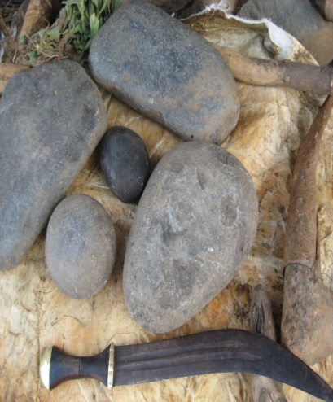
The symbolic representation and interpretation of folk medicine collecting tools and days:
Horn knife, Spear (specially, back to the battle field and touch a human blood), A new mortar ,A new stone , Brass pots, Horns of various animals, Big black Stone, Small finger (for measurement),Holy water(early morning fiche water)

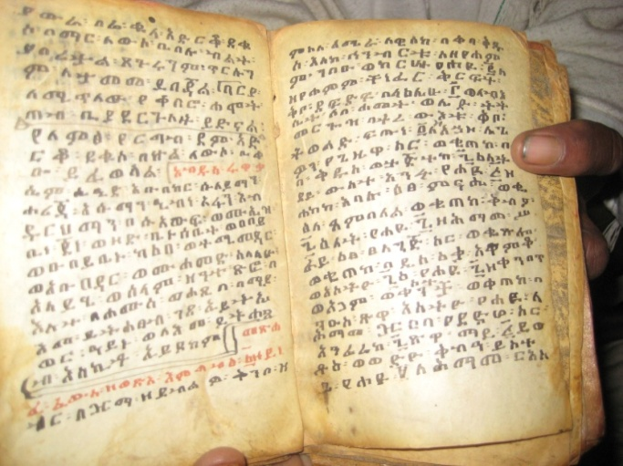
Acquiring and transferring systems of folk medical knowledge through: family by hereditary; traditional Written record and books (like ”etse debdabe” and “metsihafe fews” traditional book/traditional Pharmacopoeia); application; non-formal education(apprenticeship or church education; loyal and servant with professionals; local communication networks; dreams and alleged contacts with ancestral sprits.

Personal Anecdote
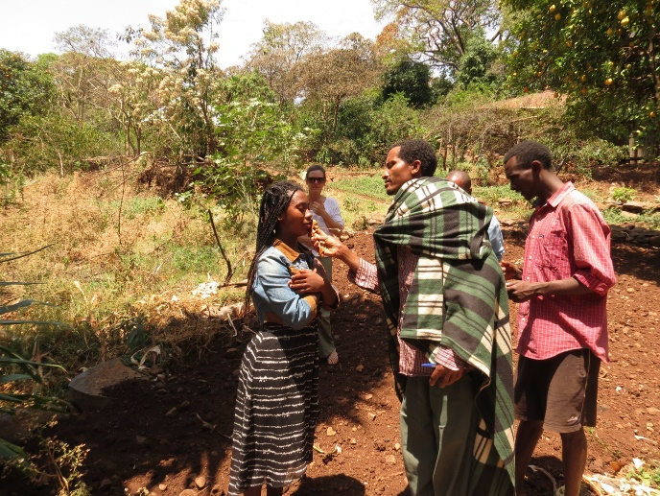
This is Michelle’s daughter, Emawayat being baptised at a monastery in Bahir Dar. Following the ceremony Temesgen was able to explain the levels of training the priest had received and his access to a language that only those trained at certain levels learn and are allowed to use. He was also able to tell Michelle what occurred according to religious and magical phenomena during the ceremony.
We accept that two of the main qualities we have intuitively established are: 1) a willingness to share knowledge, and 2) trust. Wasser and Bresler (1996) find that there is a “special kind of trust that nourishes dialogic inquiry, and that is the trust that members must have for the group and its members to tolerate ambiguity, sustained moments of misunderstanding, not sharing the same views, continuing the discussion even when it makes one uncomfortable, and not being forced into one position or another (p.10). Trust is a quality that has to be perceived at conscious and subconscious levels.
1.3 የባህላዊ ህክምና ንድፈ ሃሳባዊ ማዕቀፍ /Theoretical Framework/
ቅይጥ ህክምና
የ ፎክሎር(የባህል ጥናት) ፕሮግራም
ምንጭ:-(Young 1970፣ 28; Yoder,1972: 192, Mekkonen , 1988፣82፣ Wondwosen , 2006፣ 32)
Above is a diagram of the framework from Temesgen’s paper.
The Frame Work of Folk Medicine (in Ethiopia)
Folk medicine is based on folk theories, beliefs and experience, that are handed down from generation to generation (Mekonnen 2008, p.15). Usually, Folk medicine is essentially two varieties, two branches: 1) natural (rational or secular) folk medicine 2) magi co-religious (magic or spirituals). Under the natural folk medicine; herbal (herbalist), chirurgeons (bone setters), tooth extractors, midwives, cuppers, tattooist are categorised. The second magic or ‘’occult’’ folk medicine include; seer or wizard ‘’debtera’’ (cleric, diviner, sorcerer, healer), shamans, witchdoctor, forecasters. These are attempts to use charms, holy words, amulets and holy actions to cure diseases (Mekkonen 1988, p. 83; Wondweson 2006, p. 32-34; Yoder 1972, p. 192-203; Young 1970, p. 28).

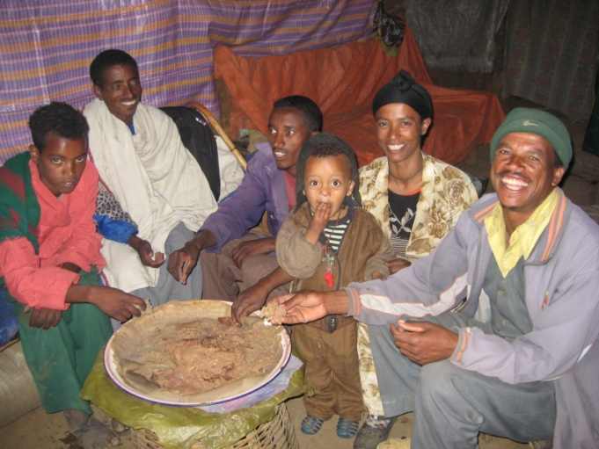
The family members attending their lunch on the dish (Rural Family)
Photograph fig.1; archive section copy 2222, canon IMG-5436 (this image have a video, code No 5445)

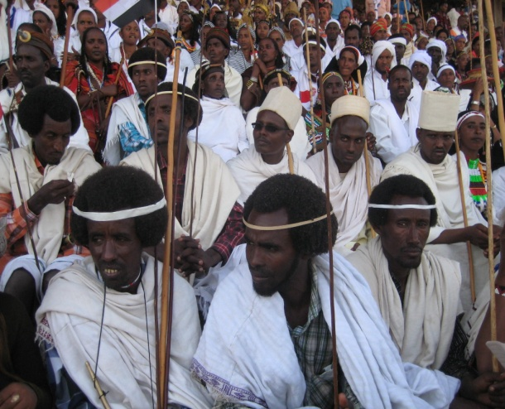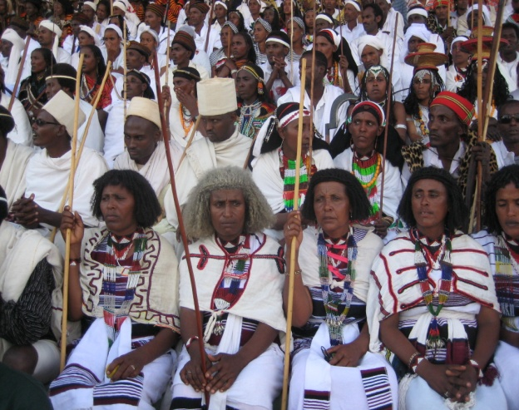
Phot.g. fig.4; archive section Canon 180, IMG-0213 Phot.g fig.3; archive section Canon 180, IMG-0210

A sample of our email correspondence
The record of the way our collaboration has been progressing intuitively and pragmatically is revealed in this sample of email correspondence, following our meeting in May 2014.
Temesgen has generously communicated in English and translated Amharic for Michelle.
TB to ME
Dear Elmitt
Thank you very much your swift response. When I was a field and now I’m doing the Amhara people folk medical practice (Preparations, prescriptions and administrations) and their challenges…, and I try to search same resource and materials about our discussions. So, you were decided to do some research in a village in ‘’Paje’’. I will post a few informants to help us for our collaborative research work. So, I’m happy to work with you and engaged with in the field. Finally, I will try to survey Endelgate short stories book (about street children) from the market place.
Best!
Temesgen, Beyene
Folklore (Cultural Studies) Department head
Bahir Dar University
May 14
There were occasional difficulties with formalities of language.
ME to TB
Thanks for that valuable information! I am really pleased about the presentation too. I'll get some ideas with my supervisor next week and look into getting the Memorandum of Understanding… He is also keen for me to buy some English versions of Ethiopian writing if you know of any?
Also I have confused you with my name. The name I go by is Michelle. Elmitt is the family name. Nicholas is my son who also emailed you earlier. I think we put our names in the different order?
Next week I will work on MOU and we can get some ideas on a way to present our collaboration at the conference! 27/7/14

We share literature and field findings as we go, not on a predetermined basis.
TB to ME
Dear Elmitt
Really, I thank you very much your response. My presentation is English, because it is a national scholar’s conference and our medium of instruction is English, and I attach here tile now what I do and (for public work and community service presentation must be use Amharic/local languages). I will send you my document on Monday, my profile (bio) and recommendation latter (about my qualifications and experience from my university) if it is relevance for you. At the present, I see your ‘Doctoral research skills portfolio” critically and I will send my valuable suggestion soon. Have a great day! 30/5/14
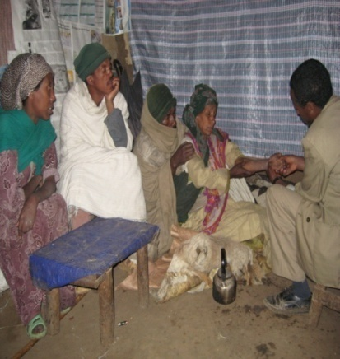
Photograph.2, a folk medical practitioner on the way of diagnosis

We have found a way to work together without a formal arrangement such as a MOU.
TB to ME
O! My God! I’M so sorry my benign lateness! And thank you very much Elmitt; for your e-mail message (now I see for your post mail on Apr. 27, May 7 and 4). I had been field work for the last three weeks, and now I came back to my regular work. How was it your Zanzibar trip and your daughters? I think; now you are arranged and organized things (like your Proposal paper and our memorandum of understanding) and you will post me; what you have to discuss me. Finally, I’m very happy what you had been doing for our practical collaboration and engagement for the international research. So, I hope, we will have a nice time to discussions about our partnership research work. I wish to you and us a nice working time. 10/5/14
We both always have the agenda of the other in mind and are trying to plan the timing for the field work.
ME to TB
Anyway, all is well and you have been busy with field work. What are you working on at the moment?
We had a really good trip to Tanzania and I also decided to do some research there, in a village in Paje where the parenting is a joint responsibility of many households, many are polygamous.
I'm just refining the proposal and so will send you a copy …
10/5/14

TB to ME
Nicholas, in April somehow I'm busy, but July and August a good time for me: b/c end of the academic calendar year. Anyway I will post the an teaches message tomorrow. i wish to you have a nice time.
Temesgen
10/7/14

TB to ME
Thank you very much for your mail and I’m fine Elmitt, how are you and your daughters? The MOU is not as such necessary for our collaboration (In our practice, to share knowledge, sharing experience, teacher exchanging, collaborative research work…are Common), but things to be institutionalized and formal communications are essential to researchers whatever we can do and maybe we need to assisting, I believe that they will support us. So, I will search my faculty experience and sends to you. On the moment, I see the abstract; it’s a very nice framework and explicitly shows what we will do. And I will suggest and send a few resources to the ‘Doctoral research skills portfolio” in a week. But instant I’m late; I was in field with my student’s for field trip to a week.
Yes! I am happy will work with you, and be present at or participate on a presentation. On the jiffy, I'm too busy and I will have a research paper to present the national Social Science and humanity faculties research conference hill in Bahir Dar University on June 08/09, 2014. Have a nice working and health time.
29/5/14

ME to TB
…I've also cut out the research in Tanzania and left it for only one study of ten participants in Ethiopia. I will meet them twice: 2015 and 2017. Is April a good time of the year for you?
On another note, I have just been reading an essay by Meyer fortes (1957) on fatalism in a west African society. It is really interesting and relative to me but I don't have an understanding of how the individual in Ethiopian society functions according to beliefs such as fatalism. Are you able to share your knowledge with me of how this works from your ethnographic experience?
2/7/14

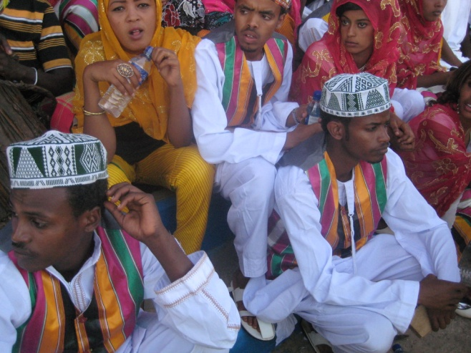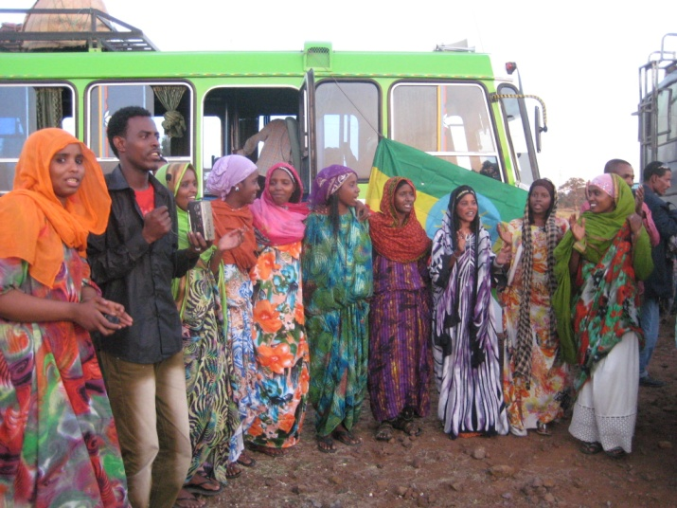
Phot.g fig.19; archive section Canon 180, IMG-0309 Phot.g. fig.8; archive section Canon 180, IMG-0097

We are aware of assisting each other’s work as a mutual responsibility.
ME to TB
Hi Temesgen,
how are you?
sorry for the delay, I've had a few emails from my supervisor and they're not sure about the MOU. they evidently usually do them for teacher exchanges not research students. Do you have anything from your Dept. I can show them?
I've done up a draft for the Abstract for the Symposium. See what you think. I hope we should be right to submit it next week when Emi is away on a camp!
May22
ME to TB
Hi Temesgen,
…Firstly I just submitted the abstract. if you want to log on to look at it the username is elmitt and the password is temesgen. We have until October to write the paper from our two perspectives…
I'm going to try to finish my ethics application today.
I hope things are going well for you. We are all well and hard at work. We had a reception for Ethiopian national day last week with the Ethiopian ambassador and lots of Ethiopian and government people as well as all the adoptive families with Emi and lots of women in national dress. It was lovely with a big cake and speeches and dancing at the end.
Take care, we'll be in touch,
June 15
TB to ME
Oh! My God! I’m fine and well, and thank you very much for you message, how about you? The last three weeks I have been field work in the country side and tomorrow I will go to Addis Ababa with my family, and a few reference book a was collected about the Ethiopian family structure and the adoption habits, farther more I will have a chance to search additional resource to find out, so I will post to you. by the way, I have been got two key informants(the adopted children and their family).
10/7/14

TB to ME
wawoo!! Congratulations again! I’m fine and well…The last weeks, I was absent from the line. How about you now and you’re doing? The term of “adoption” is translated to Amharic/Oromifa language is “Gudifcha”. The root word comes from the Oromo nation’s language. According to your source, Meyer fortes (1957) V111 cited, “Fatalism“, the tendency and activity of “Fatalism” in Ethiopian society vary place to place, and nations to nations, because of their religious concept, belief, customs, norms and values, and rituals …vary. Eg. One of the Ethiopian Oromo nations, particularly “the Balle Oromo” tribe used an exemplary adoption system. Maybe, children lost their parents (Father and Mother), The village leader calls their bloody kinship relationship with the children. Then, the village leader selects one of them economically, socially, ethically, and psychologically wellbeing person to adopt the children. During the occasion the villager had done some ritual activities and the adopted person get in Oath (That is Fatalism, the religious father bless the adopted person and coin holly bible/ or coin their ancestor worship…In fact, this is the basic function of the whole social structure are band together), to grow up the children properly without any separation, and discrimination from his children’s. The rest relative close family is to check the children grow up over all conditions informally. So, “Fatalism” is the common practice in Ethiopian people, nations and nationality, but their customs, rituals and religious background differ nation to nation.
I’m inspired on your work and activity, and I try to searching materials to helping us and I will search a scholarship in related fields of Cultural Studies or Folklore (MA/other or PhD) stream. 27/7/14
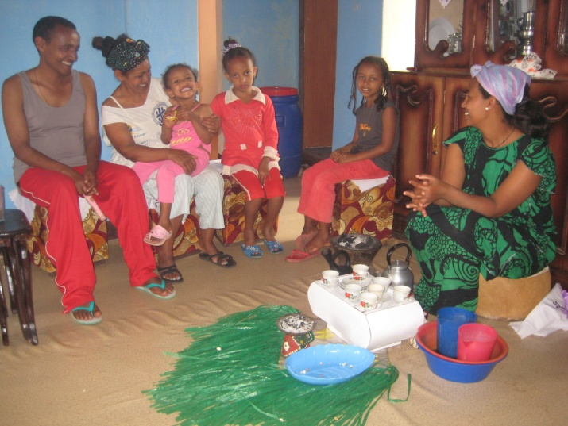
Photograph fig.2; archive section Canon 180, IMG-7871
The family members attending the coffee Ceremony rituals (Urban Family)

TB to ME
Dear Michelle
Thank you very much for your mail and a kindly corrected me about your name. The MoU, In my faculty and department has commonly used institutional dual beneficiary activities (like, research working by institutional level, exchange professionals, scholarship, sheering experience, short term training etc ). I think your work (PhD)/our work and cooperation have behaved of our institution, but more of our work and goals are individual agreement and cooperation work. So, it’s enough to we will announce our plan what we will do? But, you will have a big goal and visions to cooperate the two institutions; you will have must be preparing the MoU. The MoU is commonly understood institutional level for us not essentials, what do you suggest me? I think exceptional tricks to prepare MoU for personal activities. So, it’s sufficient to announce our work to our institutions.
I had been searched and survey a few research materials regarding to our works (Adoption) in Addis Ababa University. And I saw and understood the overall works and their recommendations were shows:-
Sisai (1992)…the traditional adoption culture to confine with modern concept of adoption by concerned Authority {the 1960, Adoption legal law…{the ritual and customs of adoption systems }…greatly reduced the importance and traditional features of adoption… it is being practiced still in traditional manner in the rural areas.
Assefash(1988,P11)…the main purpose of adoption in Amhara society is to get righteousness from God.
For all, currently our government and local elders are concern the way of adoption system, bonds between adopter and adoptee, legal law and the future grow up life of child.
Michelle, what kinds and teams (title) of English versions books you went to buy? Regarding to adoption I will buy, cope and collect reference/bibliography. Because, this is my task and duty,I will collect and forward to you. Finally, I attached here, a few reference books and thesis. I wish to you a nice working time.
Best!
Temesgen
Aug 2014
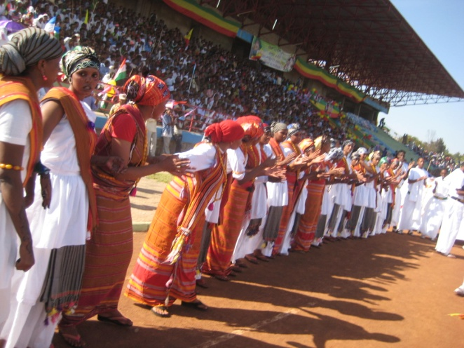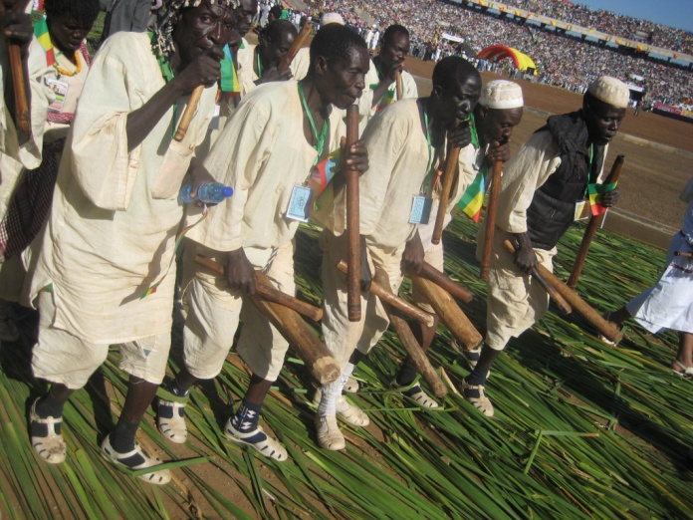
Phot.g. fig.10; archive section Canon 180, IMG-0165 Phot.g fig.15; archive section 7th Bahir Dar, IMG-0514

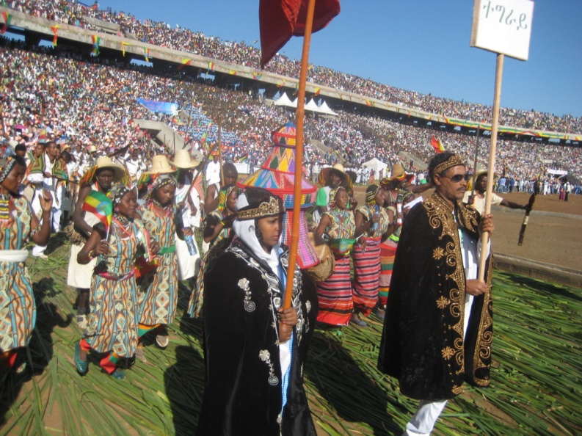 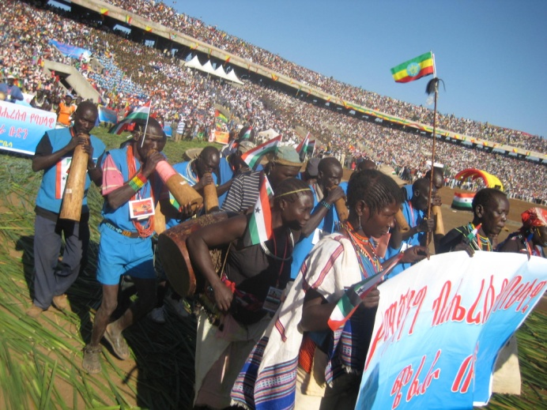 Phot.g fig.20; archive section Canon 180, IMG-0517 Phot.g fig.17; archive section 7th Bahir Dar, IMG-0490
Results
Collaboration Outcomes
Reflexively we can say that while Temesgen was willing to correspond in English and Michelle was not able to converse in Amharic, we managed to progress through some issues about what a formal research arrangement may entail, while moving on simultaneously with the actual plan for the fieldwork and the sharing of information in the form of photographs and reference material back and forth. We continue to work through the challenges of intercultural research keeping the differing perspectives of the researchers alive. Issues such as translation, time constraints and the overwhelming nature of carrying out field research in a field previous unknown to the researcher, are discussed. Above all we have benefited from our pragmatic approach and the trust we have established.
The points we take up from the literature review of various models of collaborative international, intercultural research and our responses are as follows:
- We are not collaborating due to funding obligations or publishing obligations. Our motivation is marked by sincerity and our practice is informed by will to knowledge.
- Problems within teams of personal and political nature with varying ontological frameworks and personalities. We embrace these differences and provide for them as we have outlined in the methodology.
- Problems of time shortages (that have to be paid for). We are on a restricted budget and will manage accordingly. This has been factored in from the initial planning. We are able to make use of technology and shared information with colleagues.
- Problems with language and cultural translation. Again we look to our methodology: interpretivist paradigm with methodology that includes ethnography, semiology, reflexivity and the creative writing process, as well as reference to Africanisation rather than dominant western paradigms.
- Is there place for student international collaboration research efforts? There are no standards to apply at present regarding formal arrangements. Luck and intuition have worked well for us.
- How do we match ethnographic field research to theory? Aligning Michelle’s Doctoral thesis with Postcolonial and Poststructural theory we have designed the field methodology to allow space to discover the subject in the context of embedded social relations that include emotional phenomena, with researchers clearly situated as actors.

Comparing our progress to the literature, in which there is little on this type of relationship, and searching for commonalities and differences, we find we are a unique team with untapped potential.
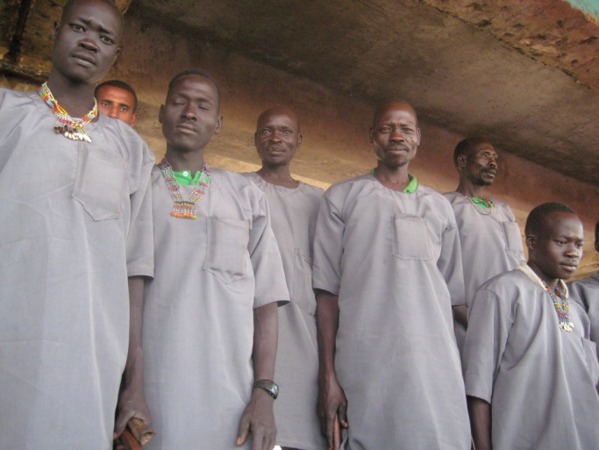
Phot.g. fig.16; archive section 7th Bahir Dar, IMG-0280

Discussion
Our field research is still in the planning stage and waiting for ethics approval, but our collaboration continues to build. This reflexive case study on our partnership promotes the value we put on keeping two perspectives when examining complex social and emotional realities, and the multi-disciplinary nature of our collaboration, which includes: ethnography, folklore and creative writing,
The collaboration outcomes will be original, like our collaboration itself. So, to answer the questions: what does he get out of it and what does she get out of it? We believe we have a chance to uncover something new about kinship experiences and something new about research methodology, by maintaining two perspectives while examining one big subject. Of all the new insights generated by our case study, perhaps the most striking finding is that the simplicity and directness of our pragmatic approach to meeting, communication, planning and sharing knowledge, has allowed us to sidestep many of the issues reported in the literature on international, multi-sited research collaborations.
And so, like Achebe’s mask dancing, we carry on our journey, seeing things from all angles: physical, emotional, cosmological. Dancing is as intuitive, creative and responsive as an inter-cultural researcher needs to be.

References
Ahmed, A 2004, The Cultural Politics of Emotion, Edinburgh University Press and Routledge, New York.
Alberti, B, Fowles, M, Holbraad, Y, Marshall, & Witmore, C 2011, ‘Worlds Otherwise: Archaeology, Anthropology, and Ontological Difference’, Current Anthropology, 52, no. 6, pp. 896-912.
Bhabha, H 1994, The Location of culture, Routledge, U.S.
Butler, J 2000, Antigone’s Claim: kinship between life and death, Columbia University Press, New York.
Chilisa, B & Preece, J 2005, Research methods for adult educators in Africa, Co-published UNESCO, Germany & Pearson Education, South Africa.
Dundon, T & Ryan, P 2010, ‘Interviewing Reluctant Respondents: Strikes, Henchmen, and Gaelic Games’, Organizational Research Methods, vol. 13, no. 3, pp. 562-581.
Easterby-Smith, M & Malina, D 1999, ‘Cross-cultural Collaborative Research: Toward Reflexivity,’ Academy of Management Journal, vol. 42 no.1, pp. 76–86.
Engelbrecht, L, Spolander, G, Martin, L, Strydom, M, Adaikalam, F, Marjanen, P, Pervova, I, Sicora, A & Tani, P 2009, ‘Reflections on a process model for international research collaboration in social work’, Journal of Management Inquiry, vol.18, pp. 313- 327.
Geertz, C 1973, The interpretation of cultures: selected essays, Basic Books, New York.
Gille, Z &O Riain S 2002, ‘Global Ethnography’, Annu. Rev. Sociol., vol .28, pp. 271–95.
Hammersley, M 1990, ‘What's Wrong with Ethnography? The Myth of Theoretical Description’, Sociology, vol. 24, pp. 597-615.
Hine, C 2007, ‘Multi-sited ethnography as a middle range methodology for contemporary STS’, Science, Technology & Human Values, vol. 32, no. 6, pp. 652-671.
Jarzabkowski, P, Bednarek, R & Cabantous, L 2014 ‘Conducting global team-based ethnography: Methodological challenges and practical methods’, Human Relations: 0018726714535449.

Jonsen, K, Butler, C, Mäkelä K, Piekkari, R, Drogendijk, R, Lauring, J, Lervik, J, Pahlberg, C, Vodosek, M & Zander, L 2012, ‘Processes of International Collaboration in Management Research: A Reflexive, Autoethnographic Approach’, Journal of Management Inquiry, vol. 22, no. 4, pp. 394–413.

Karra, N & Phillips, N 2008, ‘Researching “Back Home” International Management Research as Autoethnography’, Organizational Research Methods, vol. 11, no. 3, pp. 541-561.

Marcus, G 1995, ‘Ethnography in/of the World System: The Emergence of Multi-Sited Ethnography’, Annual Review of Anthropology, vol. 24, pp. 95-117.
Mbembe, A 2001, On the Postcolony, University of California Press, US.
Ou, A, Varriale, L & Tsui, A 2012, ‘International Collaboration for Academic Publication: Implications From the Resource-Based View and Transaction Cost Theory’, Group & Organization Management, vol. 37, no. 4, pp. 407–451.
Povinelli, E 2002, ‘Notes on Gridlock: Genealogy, Intimacy, Sexuality’, Public Culture, vol. 14, no. 1, pp. 215-238.
Povinelli, E 2006, The empire of love: toward a theory of intimacy, genealogy, and carnality, Duke University Press, Durham, U.S.A.
Said, E 1989, ‘Representing the Colonized: Anthropology's Interlocutors’, Critical Inquiry, vol. 15, no. 2, pp. 205-225.
Siemens, L, Cunningham, R, Duff, W, & Warwick, C 2011 ‘A tale of two cities: implications of the similarities and differences in collaborative approaches within the digital libraries and digital humanities communities’, Literary and Linguistic Computing, vol. 26, no. 3, pp. 335-348.
Siemens, L, Burr, E 2013 ‘A trip around the world: Accommodating geographical, linguistic and cultural diversity in academic research teams’, Literary and Linguistic Computing, vol. 28, no. 2, pp. 331-340.
Thomas, R, Tienari, J, Davies, A & Meriläinen, S 2009, ‘Let's Talk about "Us": A Reflexive Account of a Cross-Cultural Research Collaboration’, Journal of Management Inquiry, vol. 1, no. 18, pp. 313-324.

Van Maanen, J 2006, ‘Ethnography then and now’, Qualitative Research in Organizations and Management: An International Journal, vol. 1, no. 1, pp. 13-21.

Wasser, J & Bressler, L 1996, ‘Working the interpretative zone: Conceptualizing collaboration in qualitative research teams’, Educational Researcher, vol. 25, no. 5, pp. 5-15.
Wittgenstein, L 1958, Philosophical Investigations, Blackwell Publishing, U.K.

