A mixed methods design to investigate student outcomes based on parental attitudes, beliefs and expectations in mathematics education

Introduction
The research related to this paper was focused on gaining in-depth insights about parental involvement in mathematics education of their children and how this involvement could be supportive for, or a pressure on, children. Hence, it was of interest to study the parent-child interaction or relationship in mathematics education within different cultures, gender, and year levels. While reviewing research on parental involvement factors, it was found that the theories and concepts employed in previous studies were inter-related. Because of such complexities in the concepts discussed in literature, the methodology of this research involved a conceptual framework and a sequential explanatory mixed methods design to analyse and interpret the quantitative survey data and qualitative face-to-face interview data. The choice of an appropriate mixed methods design and its development process are discussed in this paper.
Background of the study
Firstly, the study aimed to identify factors of parental involvement which positively or negatively affect secondary school children and influence their mathematics education due to parental attributes such as attitudes, beliefs, standards, expectations, and aspirations. Secondly, differences in parental involvement due to cultural background, gender, and year level were investigated. Thirdly, the study looked into details of parental involvement factors and found out which areas might cause positive and/or negative outcomes on children. Finally, the findings were combined and discussed to strike a balance between positive and negative outcomes of parental involvement in mathematics education of their children.
Hence, the research questions in the study were as follows:
- What parental involvement factors with direct parent-child interaction positively or negatively affect student outcomes in mathematics education of secondary school children?
- How do the parental attitudes, beliefs and expectations and parental involvement in mathematics education vary
(a). between Asian-Australian and European-Australian backgrounds?
(b). between genders of children?
(c). among year levels of children?
3. (a). Within the identified factors of parental involvement, which areas can cause positive and/or negative outcomes on mathematics education of secondary school children?
(b). What is an appropriate balance between positive and negative outcomes of parental involvement?
Review of the literature provided some information about the possible factors that could be included in the answer to research question 1. Additionally, there were other factors that required analyses using quantitative and qualitative techniques. Quantitative data were more appropriate to answer research question 2 and qualitative data were preferable to research question 3. Hence, this study had a mix of both quantitative and qualitative research questions which implied the necessity of mixed methods research design. Using the information in literature, general beliefs, and the researcher’s experience as a student, parent, teacher, and tutor, a conceptual framework was developed to guide the research process. Hence, the framework was a combination of prior research and experiential knowledge. As described by Ravitch and Riggan (2012) the use of a conceptual framework would shape the design and direct the study towards its evolution.
Conceptual framework
Although a theoretical perspective may be present in a mixed methods design (Creswell, Plano Clark, Gutmann, & Hanson, 2003), this study involved a conceptual framework to understand the connections among parental attributes, factors of parental involvement, and student outcomes. As Punch (2014) explained, a conceptual framework is a representation of main concepts or variables and their presumed relationship with each other. Out of the many factors which are related to parental involvement in mathematics education, the conceptual framework in this study focused on the factors that could be considered as most relevant to secondary students.
Factors in literature which were directly related to parents and children such as parental encouragement, family rules, home discussion, homework involvement, and perceptions of control were included in the proposed conceptual framework. Material deprivation was another factor in previous studies which refers to the inability for individuals or households to afford consumption goods and activities. With regard to parents and children in the study, this factor was modified as entertainment deprivation which was defined as inaccessibility to social media and equipment such as computer games, television, and mobile phones. Students might not be able to access such equipment due to non-availability within premises or prohibition by parents.
In addition to the factors mentioned above, another factor known as provision of private tutoring, which is common at present, was added to the list. Apart from these seven parental involvement factors, student self-concept was included which was another factor discussed in previous studies that affected student outcomes. However, it should be noted that student self-concept is not a direct parental involvement factor.
As a starting point the conceptual framework in Figure 1 was used to show how parental attributes, involvement factors and student outcomes could be related based on literature and experiential knowledge. In the conceptual framework, the most frequently spoken three parental attributes that would influence parental involvement, namely, parental attitudes, beliefs, and expectations together were included and considered as a single factor abbreviated as parental ABE. Student outcomes depending on various parental actions within the seven parental involvement factors and the student self-concept were divided into positives, negatives, and both positives and negatives depending on the effects on children.
The research questions in this study were not only confirmatory but also exploratory (Teddlie & Tashakkori, 2009). Therefore, both quantitative and qualitative data were needed to help explain answers. As a result, the study involved a mixed methods approach.

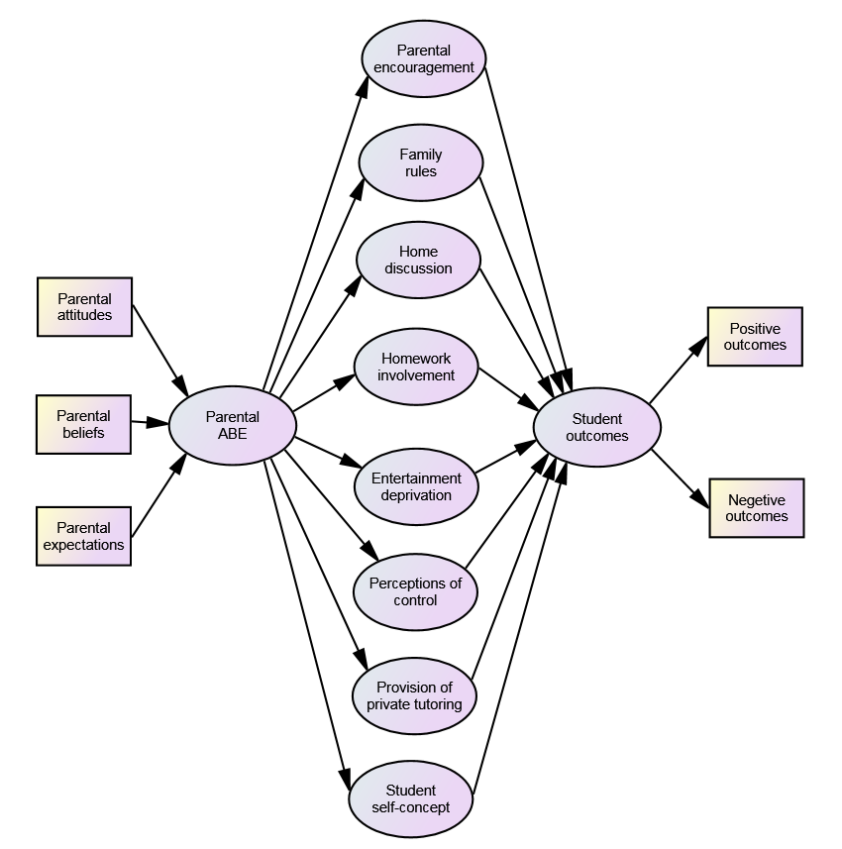
Figure 1. Conceptual framework of parental involvement and student outcomes
Research paradigm and approach
A worldview or paradigm is a set of assumptions about the world (Punch, 2014) and has implications for research methods. Tashakkori and Teddlie (1998) described four paradigms: positivism, postpositivism, pragmatism, and constructivism. Later Teddlie and Tashakkori (2009) added another paradigm to the list, the transformative perspective. They also described that pragmatism and transformative perspective are linked to, and advocate the use of, mixed methods while searching for practical answers to questions that intrigue the researcher.
Pragmatism and transformative perspective have quite divergent characteristics. In pragmatism, values play an important role in conducting research and interpreting results while in transformative perspective, all aspects of research are guided by social injustice (Teddlie & Tashakkori, 2009). As noted in literature, several researchers proposed pragmatism as the best paradigm for justifying the use of mixed methods (e.g., Johnson & Onwuegbuzie, 2004; Morgan, 2007; Tashakkori & Teddlie, 1998). Creswell (2009) described mixed methods approach as a pragmatic worldview where the researcher bases the inquiry on the assumption that the collection of diverse types of data provides a comprehensive understanding of research questions (Richards & Morse, 2007). Pragmatists believe that values are important in conducting research and the use of both quantitative and qualitative methods helps looking into more fruitful grounds that relate to commonalities and compatibilities in the study (Barbour, 2014). Hence, mixed methodologists are interested in collecting and analysing both narrative and numeric data working within the pragmatist paradigm (Teddlie & Tashakkori, 2009) where the researcher decides what to study based on personal value systems and the existing literature.
Mixing quantitative and qualitative methods can compensate for the perceived shortcomings of stand-alone quantitative or qualitative methods as mixed methods are often employed with the aim of providing a more complete picture or enhancing coverage (Barbour, 2014; Creswell & Plano Clark, 2007 ). As a result, mixed methods research either in parallel or sequential phases can answer research questions that the other methodologies cannot, provides better inferences and presents a greater diversity of divergent views (Teddlie & Tashakkori, 2003). Hence, the strengths of both quantitative and qualitative research would provide the understanding or answers to the research questions (Hesse-Biber, 2010) in mixed methods studies.
With regard to the aims of this research, which were to learn about parental involvement and its positive and negative outcomes on academic achievement of children, it seemed useful to approach both quantitative and qualitative methods. While the studies in literature, beliefs, and experiences together with quantitative techniques could provide answers to research question 1, the quantitative data would be more appropriate for comparisons required in research question 2, and qualitative data would be useful to answer research question 3. Therefore, data collection of this study began with a quantitative survey in which some of the concepts and hypotheses were tested. Next, it was followed by collecting qualitative data from detailed exploration with a few cases or individuals consisting of parents and their children. The purpose was to understand data that were complex and could be approached only in context (Richards & Morse, 2007). Hence, qualitative data in this study were for the purpose of understanding social phenomena while quantitative data were to determine relationships, effects, and causes (Wiersma, 1991). As a result, both research methods were involved and, in fact, the two methods were supportive of each other resulting a better approach to the study as described below.
Firstly, quantitative survey research provided a numeric description of trends, attitudes, or opinions of the population to be studied by studying a sample of the population (Babbie, 1990, as cited in Creswell, 2009). This survey was a cross-sectional study using questionnaires for both parents and their secondary students. Data were collected with the intent of generalising from a sample to a population. The questionnaires consisted of dichotomous closed questions including Likert scale and multiple choice types, and a few open-ended questions.
Secondly, qualitative case studies, which were detailed, holistic and in-context studies (Punch, 2014), further investigated answers to the research questions and sought a range of different kinds of evidence which had to be abstracted and collated to get the best possible answers (Gillham, 2009). Interviewing is the most prominent data collection tool in qualitative research and participant observation is the central data collection technique in ethnography (Punch, 2014). Thus, a few families including a parent and child were interviewed and observed exploring those cases in depth. The hallmark of interviewing is the use of open-ended questions which allow respondents to focus on issues of importance to them, rather than being directed in a way the researcher is interested (Barbour, 2014). Hence, the aim was to understand the cases, maintain vigorous interpretation, and draw conclusions (Stake, 1995) from qualitative data.
In this study, which was initially quantitative, there were aspects of the phenomenon that could not be measured. That was why the study began with a survey and in a second phase, focused on qualitative, open-ended, and face-to-face interviews to collect detailed views from participants, and observations. The following section describes the mixed methods design process, which guided the study.

Mixed methods design
The goal of this research design was to rely, as much as possible, on the participants’ views of the situation being studied. A mixed methods approach was chosen because of its strength to include both quantitative closed-ended response data and qualitative open-ended personal data minimising the limitations of each method. Then the findings of both quantitative and qualitative data were integrated and interpreted by bringing findings together from quantitative and qualitative data as shown in Figure 2.
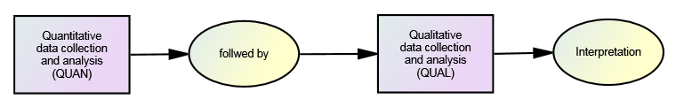 Figure 2. Explanatory sequential mixed methods design
Creswell (2014) described three basic mixed methods designs: namely, convergent parallel mixed methods; explanatory sequential mixed methods; and exploratory sequential mixed methods. Out of the three designs, this study was based on explanatory sequential mixed methods. Implementing a sequential design with the quantitative component first and qualitative second, enabled to attain an added value in interpreting results of both methods (Hesse-Biber, 2010). There are four criteria in a mixed methods design, which are named as implementation, priority, integration, and theoretical perspective (Creswell, Plano Clark, Gutmann, & Hanson, 2003). In sequential explanatory design, quantitative data collection and analysis are implemented prior to qualitative data collection and analysis while either type of data can be given priority or both can be of equal priority. The sequential quantitative and qualitative components in this study were equally important. Hence, the appropriate notation QUAN → QUAL was applicable (Creswell, 2015). The stage of integration was at the interpretation phase of the analysis. Accordingly, the procedure involved administering surveys, analysing survey data, conducting interviews, analysing interview data, and interpretation.
In practice, the recruitment of participants for the interviews and collection of qualitative data were carried out in parallel to the quantitative data analysis process. Therefore, the model in Figure 2 was further developed into an overall design shown in Figure 3, which was adapted from Creswell (2015), Ivankova and Stick (2007), and Tashakkori and Teddlie (2003).
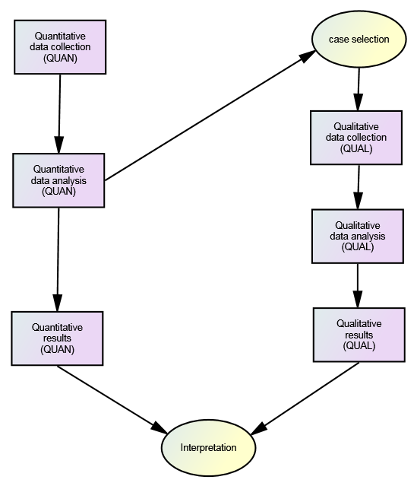 Figure 3. Detailed explanatory sequential mixed methods design
Mixed methods sampling and research participants
As explained by Kemper, Stringfield, and Teddlie (2003), there are two types of sampling techniques: probability sampling and purposive sampling. In this study, larger samples in quantitative studies were selected through probability sampling whereas smaller samples in qualitative studies were selected through purposive sampling. Probability sampling ensures generalisability or external validity by extrapolating findings to a larger population. Out of the different kinds of probability sampling techniques, cluster sampling was applicable to this study. Participating parents and children were considered as an output of cluster sampling, which consisted of a random sample of groups within a population (Kemper, Stringfield, & Teddlie, 2003). Purposive samples in qualitative studies or interviews were intentionally selected specific cases who provided best information and helped the researcher to understand the phenomenon under exploration (Creswell, 2015). Kemper, Stringfield, and Teddlie (2003) described this technique as typical case sampling. The combination of probability and purposive sampling procedures is commonly used in mixed methods where quantitative and qualitative findings are equally important.
There were various different groups of participants in the probability sample of this study. They were both male or female secondary students from year 7 to 12 and their male or female parents from Asian and European backgrounds, who live in Australia. However, the purposive sample selected from the probability sample included senior secondary students from year 10, 11, or 12 only. They were male or female students and their parents from both ethnic backgrounds. It was expected to obtain responses from parents and children using two questionnaires, which were similar to each other. Interview questions for parents and children were also similar.
With the permission of education authorities and principals, the consent forms and invitation letters were sent to schools and hard copies of student questionnaire were distributed to secondary students in four different schools without being selective in their ethnic background, gender, or secondary year level. Students were asked to take a copy of parental questionnaire home and hand in back to their teacher with one of the parents’ responses. Then the researcher collected responses to questionnaires of both parents and children. In addition, with the permission from school principals, the questionnaires were made available in school websites. This enabled students and parents to respond to the questionnaires whenever it suited for them.
After the survey using both student and parent questionnaires, from the participants who completed the survey, a purposefully selected sample of four families (parents and child separately) from each European-Australian and Asian-Australian backgrounds were interviewed. Hence, there were sixteen interviews in total, which were the main source of collecting qualitative data though it was of interest to use responses for the descriptive questions in the questionnaires too. The sample of qualitative participants were also participants in quantitative sample, ensuring better comparison between similar data from both types (Creswell, 2014). Further, while conducting face-to-face interviews each case or participant was observed. “Whatever the problem or the approach, at the heart of every case study lies a method of observation.” (Cohen & Manion, 1994, p.107). Therefore, observations during the interview process or during any other opportunity that arose when working with students and parents were recorded.

Survey instruments, interview questions, and data collection
There are three prerequisites to design any survey: which can be considered as the specification of the exact purpose of the enquiry; the population on which it is to focus; and the resources that are available (Cohen & Manion, 1994). In this study, the purpose of the enquiry was to explore views of students and parents about parental involvement in mathematics education. The population, upon which the survey was focused, consists of secondary students and their parents from four schools in Melbourne, Australia. The schools have a multicultural population of students. For the surveys, a previously used instrument (Phillipson, 2006) was adapted as parents’ questionnaire and a similar questionnaire was developed for children. Tables 1 and 2 provide some of the Likert scale questions, which show the similarity between questionnaires for parents and children.
Table 3.1. Likert scale questions from parents’ questionnaire:
No | Statements | Strongly agree | Agree | Disagree | Strongly disagree
1. | My child puts all his/her effort into school-related tasks. | ① | ② | ③ | ④
2. | My child can get better marks if he/she tries harder. | ① | ② | ③ | ④
3. | My child appreciates my feedback about his/her work. | ① | ② | ③ | ④
Table 3.2. Likert scale questions from children’s questionnaire:
No | Statements | Strongly agree | Agree | Disagree | Strongly disagree
1. | My parents believe I put all my effort into school-related tasks. | ① | ② | ③ | ④
2. | My parents believe I can get better marks if I try harder. | ① | ② | ③ | ④
3. | I appreciate my parents’ feedback about my work. | ① | ② | ③ | ④
The following are some of the multiple choice questions extracted from parents’ questionnaire. Similar questions were included in children’s questionnaire.
Q3. What is the gender of your child?
- Male
- Female

Q4. What is the year level of your child?
- Year 7
- Year 8
- Year 9
- Year 10
- Year 11
- Year 12

Q5. What is your ethnic background?
- European-Australian
- Asian-Australian
- Other - (please specify)________________________________
The following examples of open-ended questions for parents and similar questions for children were included in the questionnaires.
Q9. What is the highest level of study you expect your child to reach and what do you want him/her to do in future?
Q10. What is the highest level of study your child is likely to reach and what is he/she likely to do in future?
Another two sets of similar questions were compiled for families (parents and children). It was planned to collect answers to those questions during the structured interview process of which the content and procedures were organised in advance (Cohen & Manion, 1994). Some examples of the interview questions for parents and children are shown below.

Interview questions for parents :

- One of your friends says that parents must help their children for homework. What are your views about this? What are your rules about your child’s mathematics homework?

- What are your future expectations about your child? What do you expect your child to do when he/she finishes school?

Interview questions for children:

- One of your friends says that parents must help their children for homework. What are your views about this? What are your parents’ rules about mathematics homework?

- What are your parents’ future expectations about you? What do they expect you to do when you finish school?

Responses from both parents and children for similar questions were gathered to compare and contrast the responses. All the interviews were conducted in English and were recorded using two digital audio recorders, one as a backup, and the audio files were transcribed and checked several times before analysing.
Techniques used in data analysis
The original survey data from online questionnaires were automatically recorded in Qualtrics, which was the software used to develop the instruments. The data from hard copies were also entered manually into Qualtrics database. After finishing quantitative data collection the parent and student data files were imported into two SPSS files. To analyse quantitative data descriptive and statistical analysis techniques such as correlation, cross-tabulation, independent samples t-tests, and analysis of variance (ANOVA) were used. In order to further analyse the quantitative data, confirmatory factor analysis (CFA) and structural equation modelling (SEM) were involved using SPSS AMOS software package.
With the qualitative interview data, content analysis techniques such as coding and querying were employed, using NVivo software package to organise data. Then, data were synthesised, re-coded, and described using thematic analysis. Finally, results of both quantitative and qualitative analyses were connected together drawing interpretations to answer each research question.
Other considerations
After obtaining permission from relevant authorities to carry out the research in schools, an information sheet about the research and a consent form were distributed among principals of selected schools to seek their permission to carry out the survey and interviews in schools. All the questions they had were answered to their satisfaction. The principals had the opportunity to view any recordings and they had the right to veto some or all of that material. They could also withdraw from this study at any time without prejudice. After permission was granted by a principal, an information sheet, consent form, and the links to the parent and child surveys were published on school website or hand over to students. The responses were handled ensuring anonymity and confidentiality of participants all the time.
In the survey of this study, participants’ privacy were guaranteed by ensuring complete and total anonymity. A participant is considered anonymous when the researcher or another person cannot identify the participant from the information provided (Cohen and Manion, 1994). For the participants agreeing to a face-to-face interview confidentiality was promised by all means. Names of participants or any other personal details of identification were not used in publications. Instead, pseudonyms for names of participants and their schools were used to describe them. Although the researcher sometimes knew who had provided the information or, was able to identify participants from the responses, it was assured that the information was not available publicly.
As with stand-alone methods, it needs to establish validity of quantitative measures as well as qualitative findings in mixed methods too. In both quantitative and qualitative studies, validity serves the purpose of checking on the quality of the data and the results (Creswell & Plano Clark, 2007). The use of qualitative sample from the quantitative sample increased the validity of data in this study. In explanatory sequential mixed methods designs a large sample for quantitative and small sample for qualitative are recommended (Creswell & Plano Clark, 2007). Hence, there were 213 participants in the surveys and 16 participants in the interviews.

Summary
This paper described the use of a conceptual framework and explanatory sequential mixed methods design to study parental involvement in mathematics education of their children. It involved collecting qualitative data after a quantitative phase of data collection to study the quantitative data in more depth. In the first phase quantitative data were collected from secondary school children and their parents using two questionnaires. In the second phase purposively selected parent-child dyads were interviewed to collect qualitative data. Qualitative and quantitative data were analysed separately and at a final stage both types of data were connected to further explain the results and to find answers to research questions. Use of mixed methods enhanced the quality of this research project which has provided interesting results that would be useful for parents who involve in mathematics education of their children.
References
Barbour, R 2014, Introducing qualitative research: A student’s guide, 2nd edn, SAGE, Great Britain.
Cohen, L & Manion, L 1994, Research methods in education, 4th edn, Routledge, London.
Creswell, JW 2009, Research design: qualitative, quantitative, and mixed methods approaches, 3rd edn, SAGE, USA.
Creswell, JW 2014, Qualitative inquiry and research design, 4th edn, SAGE, USA.
Creswell, JW 2015, A concise introduction to mixed methods research, SAGE, USA.
Creswell, JW & Plano Clark, VL 2007, Designing and conducting mixed methods research, SAGE, USA.
Creswell, JW Plano Clark, VL, Gutmann, ML, & Hanson, WE 2003. ‘Advanced mixed methods research designs’, in Handbook of Mixed Methods in Social & Behavioural Research, (eds) A Tashakkori & C Teddlie, SAGE, USA.
Gillham, B 2009, Case study research methods, MPG Books, Great Britain.
Guba, EG & Lincoln, YS 1994, ‘Competing paradigms in qualitative research’, in Handbook of Qualitative Research, (eds) NK Denzin & YS Lincoln, SAGE, Thousand Oaks, CA.
Hesse-Biber, SN 2010, Mixed methods research: merging theory with practice, Guilford, USA.
Ivankova, NV & Stick, SL 2007, ‘Students’ persistence in a distributed doctoral program in educational leadership in higher education: A mixed methods study’, Research in Higher Education, vol.48, no.1, pp.93-135.
Johnson, RB & Onwuegbuzie, AJ 2004. Mixed methods research: A research paradigm whose time has come, Educational Researcher, vol.33, no.7, pp.14-26.
Kemper, EA, Stringfield, S & Teddlie, C 2003, ‘Mixed methods sampling strategies in social science research’, in Handbook of Mixed Methods in Social & Behavioural Research, (eds) A Tashakkori & C Teddlie, SAGE, USA.
Morgan, DL 2007. Paradigms lost and pragmatism regained: Methodological implications of combining qualitative and quantitative methods, Journal of Mixed Methods Research, vol.1, no.1, pp.48-76.
Punch, KF 2014, Introduction to social research: Quantitative and qualitative approaches, 3rd edn, SAGE, Great Britain.
Ravitch, SM & Riggan, M 2012, Reason & Rigor, SAGE, United Kingdom.
Richards, L & Morse, JM 2007, User's guide to qualitative methods, 2nd edn, SAGE, USA.
Stake, RE 1995, The art of case study research, SAGE, USA.
Tashakkori, A & Teddlie, C 1998. Mixed Methodology: Combining Qualitative and Quantitative Approaches, SAGE, USA.
Tashakkori, A & Teddlie, C 2003, ‘The past and future of mixed methods research: From data triangulation to mixed model designs’, in Handbook of Mixed Methods in Social & Behavioural Research, (eds) A Tashakkori & C Teddlie, SAGE, USA.
Teddlie, C & Tashakkori, A 2003, ‘Major issues and controversies in the use of mixed methods in the social and behavioural sciences’, in Handbook of Mixed Methods in Social & Behavioural Research, (eds) A Tashakkori & C Teddlie, SAGE, USA.
Teddlie, C & Tashakkori, A 2009. Foundations of Mixed Methods Research: Integrating Quantitative and Qualitative Approaches in the Social and Behavioral Sciences, SAGE, USA.
Wiersma, W 1991, Research methods in education: An introduction, 5th edn, Allyn and Bacon, USA.

